Introduction:
An essential part of working with text-generative LLMs is prompt engineering. By carefully designing our prompts we can guide the LLM to generate desired responses. Whether the prompts are questions, statements, or instructions, the main goal of prompt engineering is to elicit a useful response from the model. Prompt engineering is more than designing effective prompts. It can be used as a tool to evaluate the output of a model as well as to design safeguards and safety mitigation methods. This is an iterative process of prompt optimization and requires experimentation. There is not and unlikely will ever be a perfect prompt design.
In this section, we will go through common methods for prompt engineering, and small tips and tricks to understand what the effect is of certain prompts. These skills allow us to understand the capabilities of LLMs and lie at the foundation of interfacing with these kinds of models.
We begin by answering the question: what should be in a prompt?
The Basic Ingredients of a Prompt:
An LLM is a prediction machine. Based on a certain input, the prompt, it tries to predict the words that might follow it. At its core as illustrated in the following figure , the prompt does not need to be more than a few words to elicit a response from the LLM.
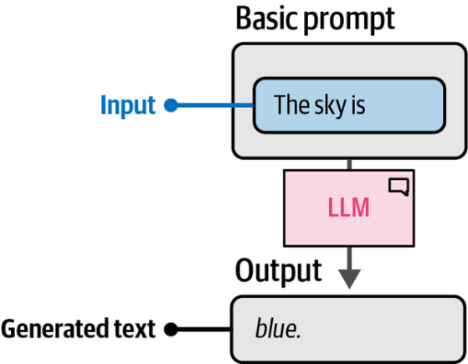
As discussed in the introduction to prompt engineering, a prompt is usually made up of several elements. In our initial example, the prompt included an instruction, some data, and output indicators. However, prompts are not restricted to these three components—you can expand and layer them to reach any level of complexity you need.
When moving beyond the basics, additional elements often come into play, which can quickly make prompts more sophisticated. Some of the most common advanced components include:
Persona
Describe what role the LLM should take on. For example, use “You are
an expert in astrophysics” if you want to ask a question about
astrophysics.
Instruction
The task itself. Make sure this is as specific as possible. We do not want
to leave much room for interpretation.
Context
Additional information describing the context of the problem or task. It
answers questions like “What is the reason for the instruction?”
Format
The format the LLM should use to output the generated text. Without it,
the LLM will come up with a format itself, which is troublesome in
automated systems.
Audience
The target of the generated text. This also describes the level of the
generated output. For education purposes, it is often helpful to use ELI5
(“Explain it like I’m 5”).
Tone
The tone of voice the LLM should use in the generated text. If you are
writing a formal email to your boss, you might not want to use an
informal tone of voice.
Data
The main data related to the task itself.
To illustrate, let us extend the classification prompt we had earlier and use all of the preceding components. We can add and remove components freely and judge their effect on the output.
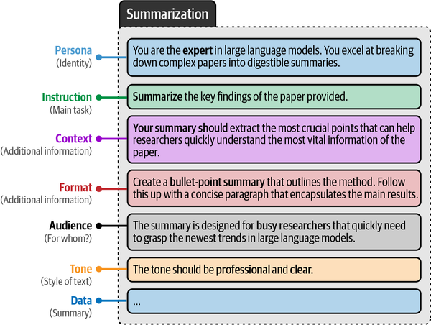
we can slowly build up our prompt and explore the effect of each change.
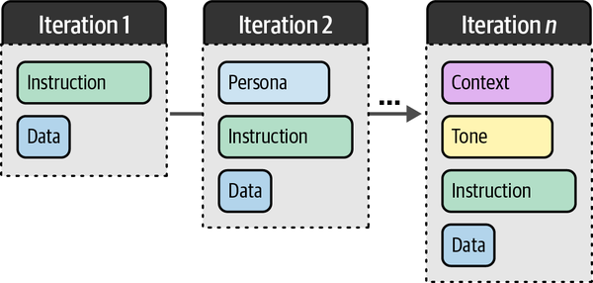
The changes are not limited to simply introducing or removing components.
In other words, experimentation is vital when finding the best prompt for your use case. With prompting, we essentially have ourselves in an iterative cycle of experimentation.
You can use your own data by adding it to the data variable:
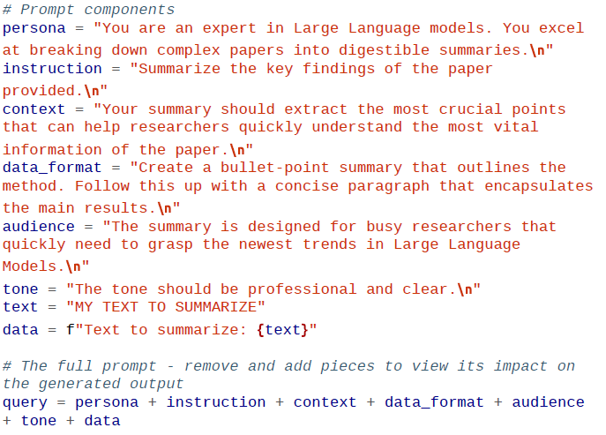
The goal of the prompt is to generate a sentence with a made-up word. To improve the quality of the resulting sentence, we can show the generative model an example of what a proper sentence with a made-up word would be.
To do so, we will need to differentiate between our question (user) and the answers that were provided by the model (assistant). We additionally showcase how this interaction is processed using the template:
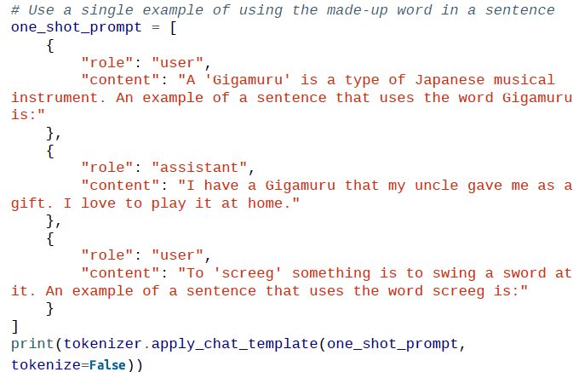
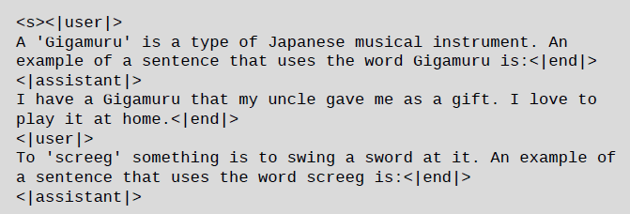
The prompt illustrates the need to differentiate between the user and the assistant. If we did not, it would seem as if we were talking to ourselves. Using these interactions, we can generate output as follows:
To generate our first text, let’s instruct the model to tell a joke about chickens. To do so, we format the prompt in a list of dictionaries where each dictionary relates to an entity in the conversation. Our role is that of “user” and we use the “content” key to define our prompt.
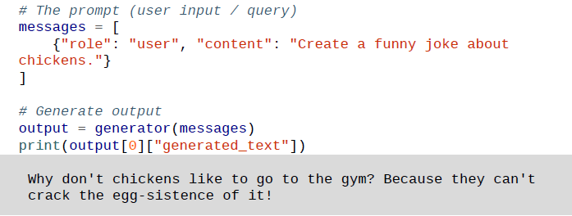
- Few Shot Prompting
Few Shot Prompting is a technique in artificial intelligence (AI) where models like GPT-3 learn to perform tasks with very few examples reducing the need for large datasets. It falls under Few Shot Learning (FSL) which enables models to adapt quickly to new tasks with minimal data making it particularly useful in situations with limited data.
Few-shot prompting works by teaching AI models through a small number of examples. Instead of retraining a model from scratch for each task, the AI is shown a few examples to understand the pattern and apply it to similar tasks.
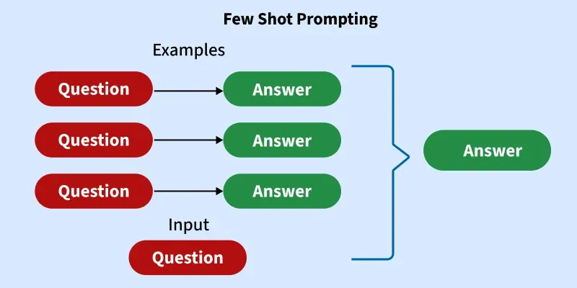
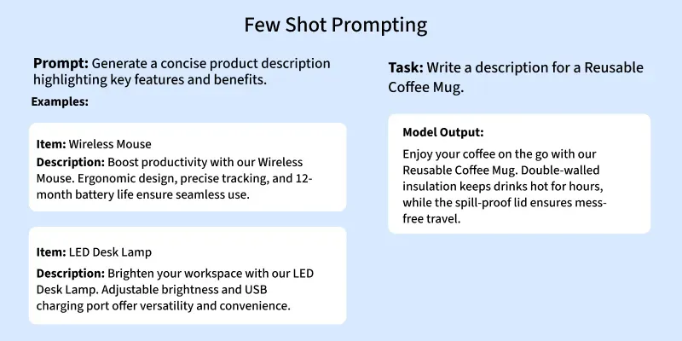

How Few Shot Prompting Works?
- User Query: Process starts when the model receives a user query, for example, "This app is really easy to use."
- Vector Store: A collection of examples, previously stored in a vector store, is used to match and find the most relevant information. A vector store is a database optimized for semantic search, which allows the system to search for the most relevant examples based on meaning rather than exact wording.
- Retrieving Relevant Examples: From the vector store, the system retrieves the best matching examples. These examples are crucial as they guide the model’s response. In some cases, Retrieval-Augmented Generation (RAG) can be used to improve the selection of examples, making sure the most relevant ones are used to form the prompt. While RAG is not always necessary, it helps improve model performance by ensuring that the examples fit well with the query context.
- Creating the Prompt: After fetching the relevant examples, the system combines them with the user query to create a clear prompt. For example, the prompt might look something like: “Based on these examples, determine the sentiment of this statement: 'This app is really easy to use.'”
- Model Processing: Model processes this constructed prompt, utilizing its pre-existing knowledge and the provided examples, then it generates an output by applying the knowledge learned from those examples to the query.
Finally, model then provides the response. For example, it might output a classification such as “positive,” reflecting the sentiment of the given statement.

Examples of Few-Shot Prompting in Action
Here are a few prompt examples to demonstrate how Few Shot Prompting works:

Example 1: Text Generation
Prompt: "Here are some examples of poems about nature. Based on these, write a new poem about the beauty of a sunset."
Example Poems:
- The sky is painted bright, the sun begins to fall,
Golden hues stretch far, lighting up the world for all.
- As the sun sets low, the stars begin to glow,
The evening breeze whispers soft and slow.
AI Output:
As the sun fades away, the sky turns to gold,
The colors blend, a story untold.
A calm breeze flows, the air turns cool,
The world sighs gently, under the moon’s rule.

Example 2: Classification Task
Prompt: "Here are a few examples of product categories and their descriptions. Based on these, categorize the following product description."
Example Categories:
- Smartphone: A device used for communication, browsing the internet and running apps.
- Laptop: A portable personal computer with a keyboard and screen, used for work, browsing and entertainment.
Product Description: "This device is lightweight, portable and has a touch screen for easy navigation and app usage."
AI Output:
Smartphone

Advantages of Few Shot Prompting
Few Shot Prompting offers several benefits:
- Reduced Data Requirements – Few Shot Prompting drastically reduces the amount of data needed to train a model for new tasks. Instead of requiring thousands of labeled examples, it can work with just a few.
- Faster Learning – Models trained with fewer examples can learn tasks faster. This is especially beneficial in time-sensitive scenarios.
- Flexibility – AI models become more adaptable, able to perform a variety of tasks without needing retraining for each new one.
- Cost-Effective – Fewer examples mean lower costs in data collection, labeling and processing, making AI applications more affordable.
- Reduced Need for Large Datasets – In domains where gathering large datasets is difficult, few-shot learning provides an alternative to traditional approaches.

Challenges of Few Shot Prompting
While Few Shot Prompting offers great potential, there are challenges that need attention:
- Reliability – Since the model is trained on fewer examples, it might struggle to generalize correctly in some cases. This can lead to inaccuracies in tasks that require more contextual understanding.
- Bias – Limited number of examples might cause the model to develop biases based on the examples it was trained on. If the examples are not diverse, the model's output might reflect these biases.
- Overfitting – With too few examples, there's a risk that the model might overfit to the provided examples, meaning it may fail to generalize well to unseen data.
- Task Complexity – Some tasks may still require more data or specialized training despite Few Shot Prompting, especially in complex domains like medical diagnosis or scientific research.

Best Practices for Few Shot Prompting
To effectively use Few Shot Prompting, consider the following best practices:
- Provide Clear and Relevant Examples – Few examples given to the model should be clear and closely related to the task at hand. This helps the model understand what is expected.
- Balance the Examples – Try to provide examples that cover the diversity of possible cases in the task. This reduces the risk of bias and improves the model's adaptability.
- Fine-tune for Specific Use Cases – If the task requires high accuracy, it's important to fine-tune the model with task-specific examples to improve performance.
- Monitor for Overfitting – Keep an eye on the model’s performance to ensure that it doesn't overfit to the few examples provided. Regular testing with new examples can help reduce this.

Real-World Examples of Few Shot Prompting
Few Shot Prompting has a wide range of real-world applications. Some common examples include:
- Translation – AI models can translate text from one language to another after seeing only a few examples of translated sentences.
- Chatbots – In customer service, chatbots can respond to queries by learning from a few sample conversations, allowing them to handle a variety of questions.
- Summarization – Models can summarize long documents or articles by being trained with a few example summaries.
By enabling models to perform tasks with just a few examples, Few-Shot Prompting is reshaping the way we approach AI, making it more efficient, adaptable and capable of solving complex problems with minimal data.
II. Chain of Thought Prompting
- Concept:
Chain of Thought Prompting is a technique that encourages AI models to articulate their reasoning step-by-step as they solve a problem or answer a question. Rather than providing a direct answer immediately, the model is prompted to break down the problem into smaller, more manageable steps, making it easier for the model to arrive at the correct conclusion.
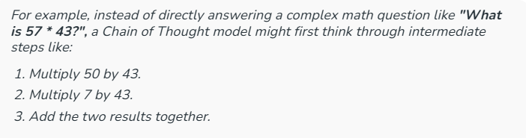
By reasoning through the steps, the model reduces the likelihood of errors and provides a clearer explanation of how the answer was derived.
In traditional AI approaches, a model typically provides an immediate response without explicitly laying out its reasoning process. However, Chain of Thought Prompting focuses on generating intermediate reasoning steps—a type of “thinking aloud” method—before arriving at a final answer. This approach improves the accuracy and transparency of the model’s decision-making process.
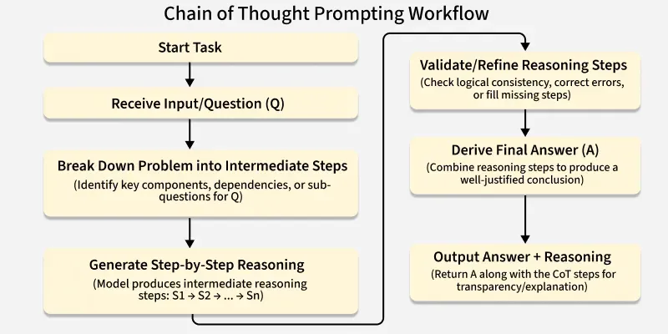
Example:
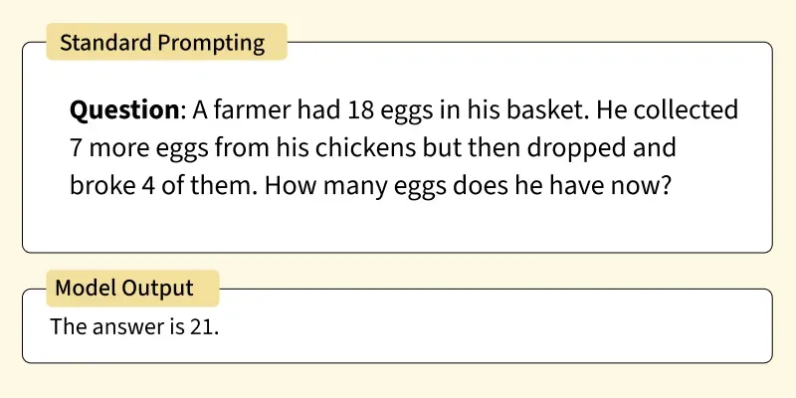
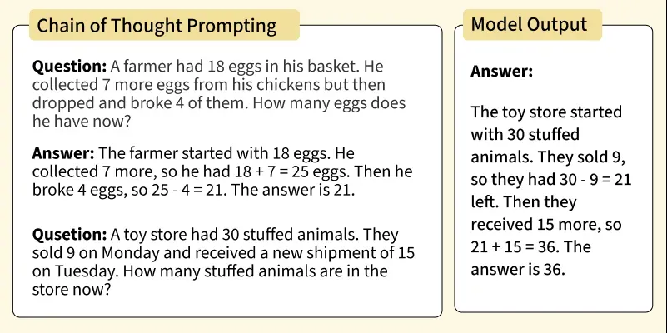

How Does Chain of Thought Prompting Work?

The process of Chain of Thought Prompting can be broken down into the following steps:
- Problem Understanding: The model is first presented with a question or problem. This could be anything from a simple factual query to a complex logical puzzle.
- Intermediate Reasoning: Instead of jumping directly to an answer, the model is prompted to reason through the problem. This step involves creating a chain of thought, where each part of the thought process leads to the next.
- Final Answer: After considering all intermediate steps, the model arrives at a conclusion or final answer. The entire process (from problem understanding to final answer) is transparent, as the reasoning steps are explicitly outlined.
- Feedback Loop: Chain of Thought Prompting can be an iterative process. If the model makes an error or fails to reach a conclusion, additional steps can be introduced, or the reasoning process can be refined to improve accuracy.
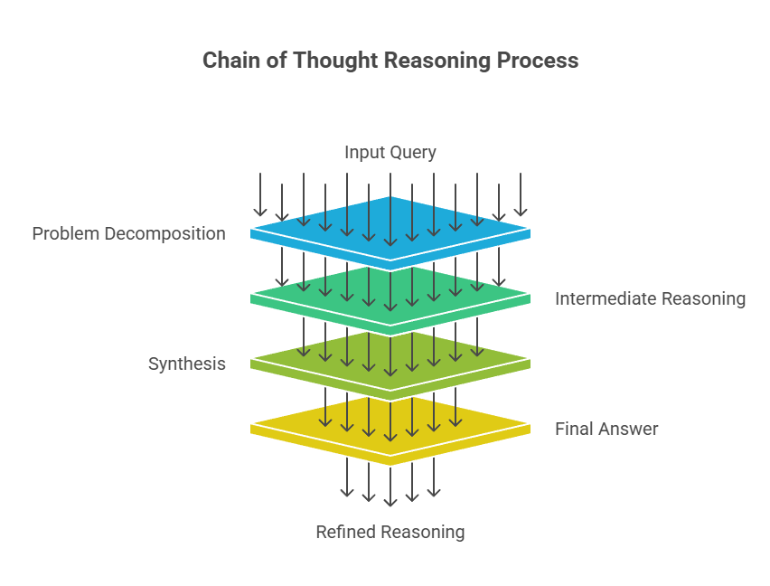

3. Applications of Chain of Thought Prompting

a. Math Problem Solving
In tasks that involve multi-step arithmetic or algebraic reasoning, such as solving equations, Chain of Thought Prompting helps the model break down the problem step-by-step.
Example: "What is 39 * 21?"
Chain of Thought:
- Multiply 30 by 21 = 630.
- Multiply 9 by 21 = 189.
- Add 630 + 189 = 819.

b. Commonsense Reasoning
CoT is beneficial for tasks requiring reasoning based on common sense, where models must consider various factors and make decisions that seem intuitive to humans but may be complex for an AI system.
Example: "If John is taller than Sarah and Sarah is taller than Tom, who is the shortest?"
Chain of Thought:
- John > Sarah > Tom.
- Therefore, Tom is the shortest.

c. Logical Puzzles and Games
CoT helps solve puzzles or games that require the model to explore different possibilities and steps. It’s particularly useful for tasks where understanding the process is as important as the answer.

d. Story Generation
When generating stories, Chain of Thought Prompting can guide the AI through the logical progression of the plot, ensuring coherence and consistency throughout the story.

4. Why is Chain of Thought Prompting Important?

a. Improved Problem Solving
Chain of Thought Prompting improves the problem-solving ability of AI models. By breaking down complex tasks into smaller, more manageable components, the model can more effectively handle challenges that require multi-step reasoning, such as mathematical problems, logical puzzles, or even questions that involve common-sense reasoning.

2. Better Transparency and Interpretability
One of the major criticisms of AI models, especially deep learning models, is that they often act as "black boxes"—meaning their decision-making process is not visible to humans. With Chain of Thought Prompting, the model's reasoning process is explicitly stated, making it more transparent. This can be particularly useful for understanding how a model arrived at its conclusion, increasing trust in the system.

3. Enhanced Accuracy
By encouraging the model to reason step-by-step, Chain of Thought Prompting minimizes the chances of making a mistake. For example, in complex math problems or tasks requiring multiple steps of logical reasoning, breaking the process down into smaller chunks allows the model to avoid skipping important steps, ultimately leading to more accurate results.

4. Application to Complex NLP Tasks
Chain of Thought Prompting has demonstrated significant benefits for more complex NLP tasks, such as commonsense reasoning, question answering, and story generation. These tasks often require the AI model to consider various possible outcomes and select the best course of action. CoT can guide the model to consider multiple perspectives and enhance the quality of its outputs.

Benefits of Chain of Thought Prompting
- Increased Accuracy: By focusing on intermediate steps, the model can make fewer mistakes and provide more accurate results.
- Better User Understanding: The transparency provided by CoT helps users understand the reasoning behind the model's output.
- Versatility: It enhances the model's ability to tackle tasks that require multi-step reasoning, including mathematical operations, logical deduction, and commonsense reasoning.

Challenges with Chain of Thought Prompting
- Complexity: Chain of Thought Prompting requires the model to generate a sequence of intermediate steps, which can be computationally expensive and time-consuming, especially in real-time applications.
- Training Data: CoT models require a significant amount of high-quality training data that includes both the final answer and the reasoning steps.
- Contextual Dependencies: In some cases, the reasoning steps may not be fully independent, and the model might struggle to maintain coherence in complex scenarios with a large number of steps.
- Memory: Helping LLMs to Remember Conversations
When we are using LLMs out of the box, they will not remember what was
being said in a conversation. You can share your name in one prompt but it
will have forgotten it by the next prompt.
Let’s illustrate this phenomenon with an example using the basic_chain
we created before. First, we tell the LLM our name:
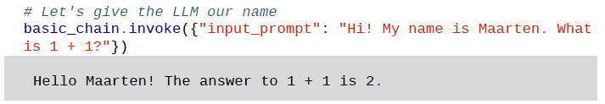
Next, we ask it to reproduce the name we have given it:
# Next, we ask the LLM to reproduce the name
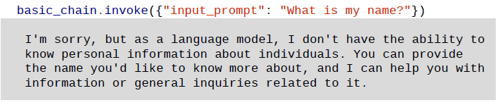
Unfortunately, the LLM does not know the name we gave it. The reason for this forgetful behavior is that these models are stateless—they have no memory of any previous conversation!
As illustrated in the following Figure , conversing with an LLM that does not have any memory is not the greatest experience.
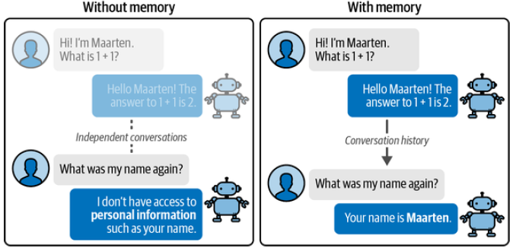
Figure: An example of a conversation between an LLM with memory and without memory.
To make these models stateful, we can add specific types of memory to the chain that we created earlier. In this section, we will go through two common methods for helping LLMs to remember conservations:
- Conversation buffer
- Conversation summary
Conversation Buffer
One of the most intuitive forms of giving LLMs memory is simply reminding them exactly what has happened in the past. As illustrated in the following figure, we can achieve this by copying the full conversation history and pasting that into our prompt.
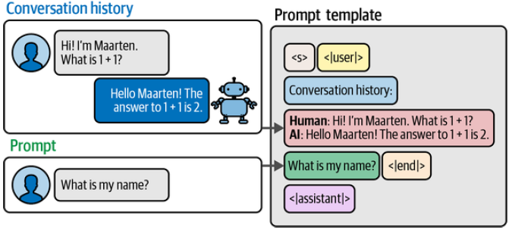
Figure: We can remind an LLM of what previously happened by simply appending the entire conversation history to the input prompt.
In LangChain, this form of memory is called a ConversationBufferMemory. Its implementation requires us to update our previous prompt to hold the history of the chat. We’ll start by creating this prompt:
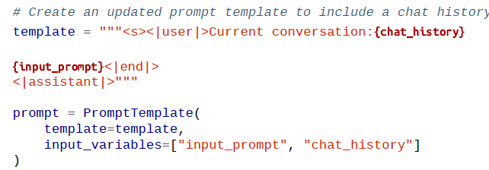
Notice that we added an additional input variable, namely chat_history. This is where the conversation history will be given before we ask the LLM our question.
Next, we can create LangChain’s ConversationBufferMemory and assign it to the chat_history input variable.
ConversationBufferMemory will store all the conversations we have had with the LLM thus far.
We put everything together and chain the LLM, memory, and prompt template:
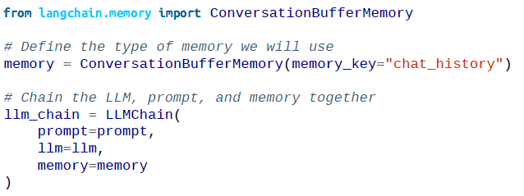
To explore whether we did this correctly, let’s create a conversation history
with the LLM by asking it a simple question:
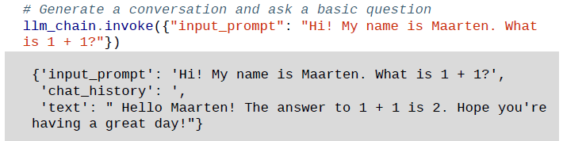
You can find the generated text in the 'text' key, the input prompt in 'input_prompt', and the chat history in 'chat_history'. Note that since this is the first time we used this specific chain, there is no chat history.
Next, let’s follow up by asking the LLM if it remembers the name we used:
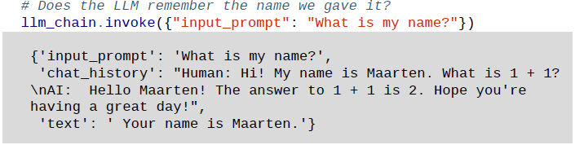
By extending the chain with memory, the LLM was able to use the chat history to find the name we gave it previously. This more complex chain is illustrated in Figure bellow to give an overview of this additional functionality.
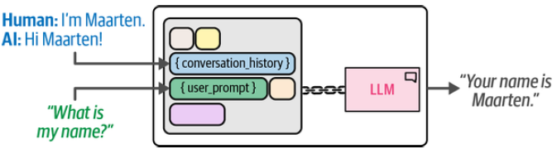
Figure: We extend the LLM chain with memory by appending the entire conversation history to the input prompt
Windowed Conversation Buffer:
In our previous example, we essentially created a chatbot. You could talk to it and it remembers the conversation you had thus far. However, as the size of the conversation grows, so does the size of the input prompt until it exceeds the token limit.
One method of minimizing the context window is to use the last k conversations instead of maintaining the full chat history. In LangChain, we can use ConversationBufferWindowMemory to decide how many conversations are passed to the input prompt:
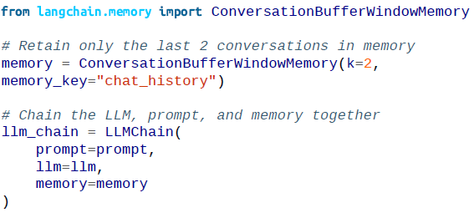
Using this memory, we can try out a sequence of questions to illustrate what
will be remembered. We start with two conversations:
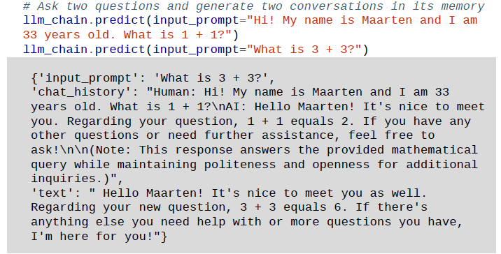 The interaction we had thus far is shown in "chat_history". Note that under the hood, LangChain saves it as an interaction between you (indicated with Human) and the LLM (indicated with AI).
Next, we can check whether the model indeed knows the name we gave it:
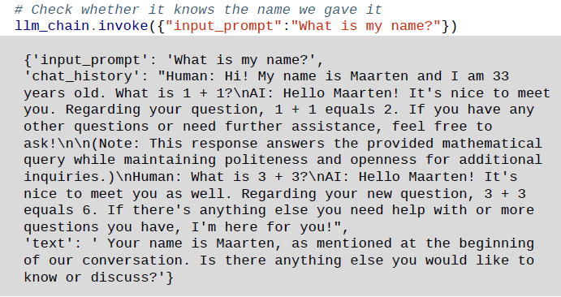
Based on the output in 'text' it correctly remembers the name we gave it. Note that the chat history is updated with the previous question. Now that we have added another conversation we are up to three conversations. Considering the memory only retains the last two conversations, our very first question is not remembered. Since we provided an age in our first interaction, we check whether the LLM indeed does not know the age anymore:
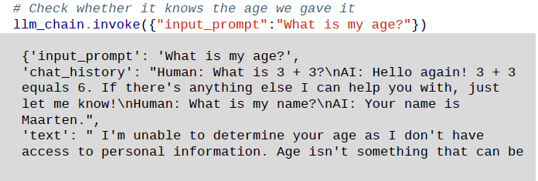
Chat Message History:
ChatMessageHistory class is one of the important classes in the modules of langchain. It is a convenient lightweight wrapper which is helpful in saving Human and AI messages and then fetching them all.
NOTE: This class is generally used if you are trying to manage the memory outside of a Chain
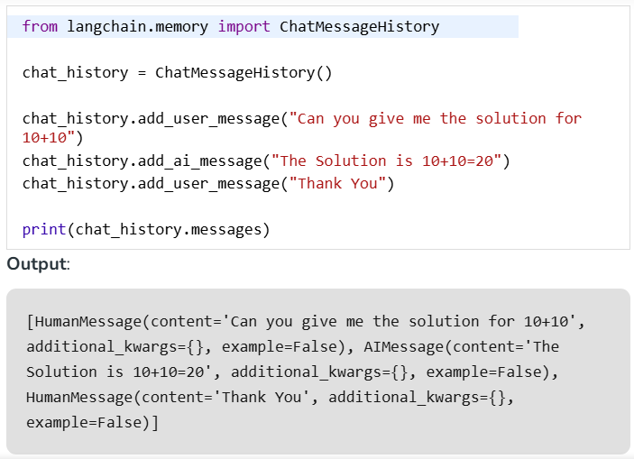
ConversationBufferMemory:
This class is a wrapper over ChatMessageHistory class and extracts messages in a variable.
Example:
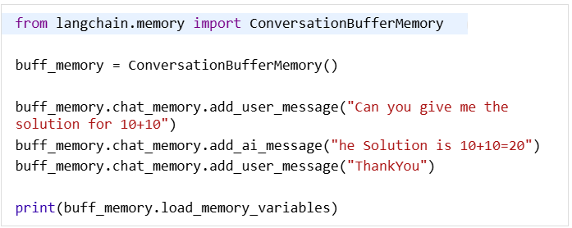
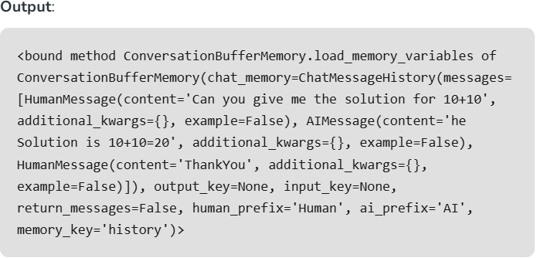

What You're Aiming For
Learn how to build an assistant that can remember previous turns in a conversation and respond according to a specific role (system persona).

Instructions
Step 1: Define the Role
- Start by writing a system message that clearly sets the assistant’s role.
  - Example:
    - System: “You are a helpful travel assistant who suggests budget-friendly trips.”
    - System: “You are a strict grammar teacher who corrects every mistake.”
Tip: The clearer and more specific the role, the more consistent the assistant will behave.

Step 2: Introduce Chat Memory
- Use a conversation buffer to keep track of past exchanges (user ↔ assistant).
- This ensures that the assistant remembers what was said earlier.
  - Example (simplified):
    - User: “I want to visit Spain.”
    - Assistant: “Great! Do you have a budget in mind?”
    - User: “Yes, around 800 euros.”
    - Assistant: should recall both Spain + 800 euros and suggest accordingly.

Step 3: Few-shot Examples (Optional)
- Provide sample dialogues inside the system or user messages to guide the assistant’s style.
  - Example:
    - System: “You are a tutor. When the student asks a question, always give a short explanation + one example.”

Step 4: Test the Memory
- Have the student try multi-turn interactions:
  - Ask the assistant to recommend something (travel, grammar fix, etc.).
  - Refer back to previous details without repeating them (e.g., “Can you suggest something else within my budget?”).
  - Check if the assistant correctly uses the stored context.

Step 5: Reflect
- After testing, the student should answer:
  - Did the assistant stay in its role?
  - Did it correctly remember past details?
  - What happens if memory is cleared or reset?
Deliverable for the student: Write a short demo dialogue (4–5 turns) showing the assistant respecting its role and remembering past context.

